Conical Straight-Line Generator

Definition
# Source: AI Source: Provided by: [Data Path: Persons Table -> ID Column: 1, Name_En Column: Motasem Essam] -> From: [ChatGPT] on [7/25/2026]
A Conical Straight-Line Generator is a straight line that moves while continuously passing through a fixed point, called the vertex or apex, and intersects a guiding curve called the directrix.
As the straight line moves around the fixed vertex and follows the directrix, it generates a conical surface.
The straight line is called the generator or generatrix, while the fixed point is the vertex of the cone.
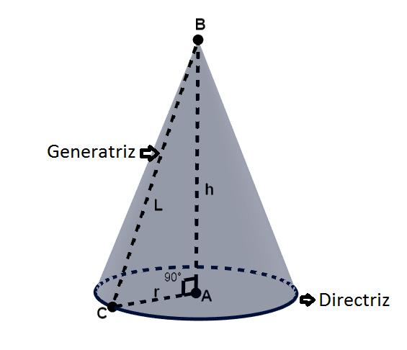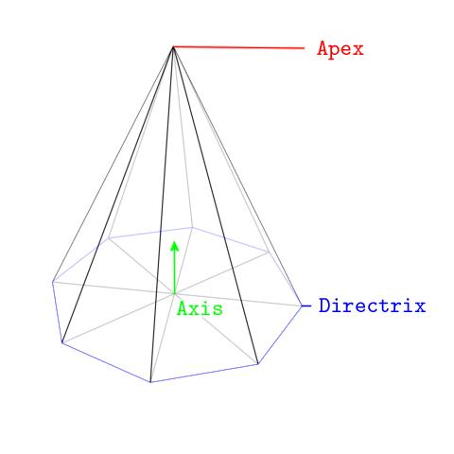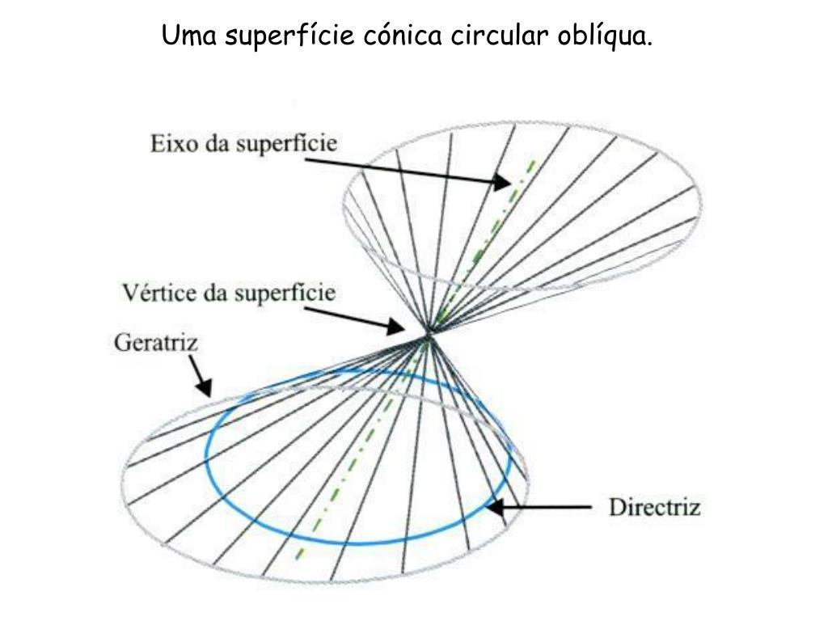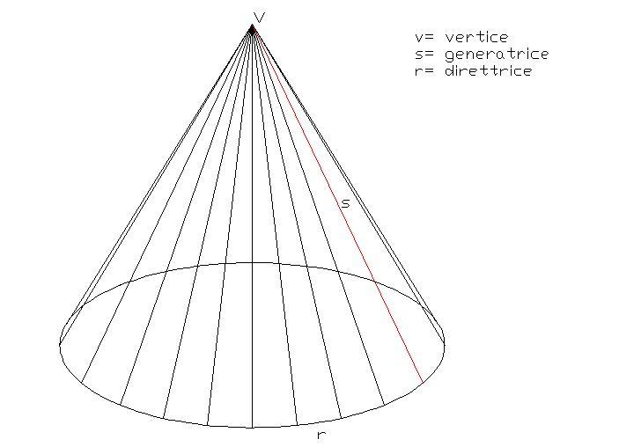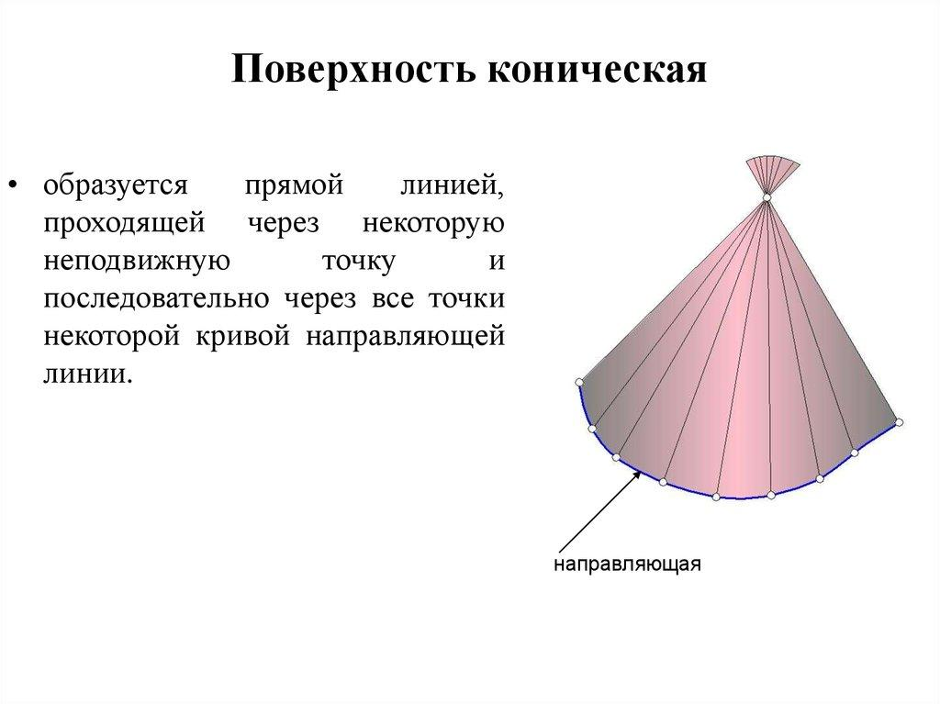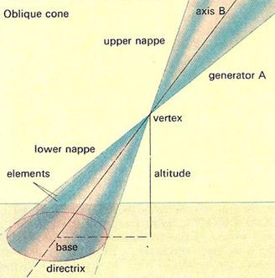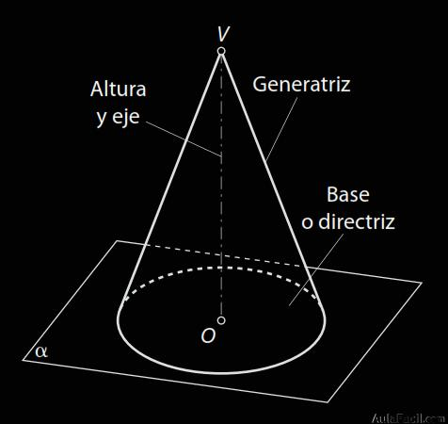
Basic generating principle:
- Fixed point → Vertex (Apex).
- Guiding curve → Directrix.
- Moving straight line → Generator.
- Generated surface → Conical surface.

Geometric Structure
# Source: AI Source: Provided by: [Data Path: Persons Table -> ID Column: 1, Name_En Column: Motasem Essam] -> From: [ChatGPT] on [7/25/2026]
A conical straight-line generator consists of the following elements:
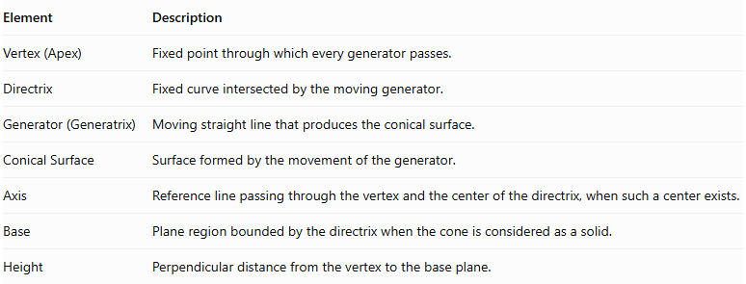
Element | Description
Vertex (Apex) | Fixed point through which every generator passes.
Directrix | Fixed curve intersected by the moving generator.
Generator (Generatrix) | Moving straight line that produces the conical surface.
Conical Surface | Surface formed by the movement of the generator.
Axis | Reference line passing through the vertex and the center of the directrix, when such a center exists.
Base | Plane region bounded by the directrix when the cone is considered as a solid.
Height | Perpendicular distance from the vertex to the base plane.

Types of Conical Straight-Line Generators
# Source: AI Source: Provided by: [Data Path: Persons Table -> ID Column: 1, Name_En Column: Motasem Essam] -> From: [ChatGPT] on [7/25/2026]
Conical generators can be classified according to the position of the vertex relative to the directrix and the orientation of the resulting cone.

Right Conical Generator
# Source: AI Source: Provided by: [Data Path: Persons Table -> ID Column: 1, Name_En Column: Motasem Essam] -> From: [ChatGPT] on [7/25/2026]
A Right Conical Generator produces a right cone in which the axis is perpendicular to the base plane.
For a right circular cone, the vertex lies on the perpendicular line through the center of the circular directrix.
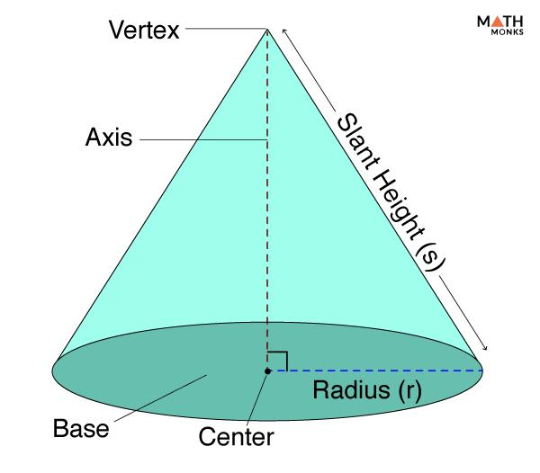
Characteristics:
- The axis is perpendicular to the base plane.
- For a circular directrix, the cone is a right circular cone.
- The generators have equal lengths from the vertex to the circular base.
- The vertex is positioned directly above or below the center of the base.

Oblique Conical Generator
# Source: AI Source: Provided by: [Data Path: Persons Table -> ID Column: 1, Name_En Column: Motasem Essam] -> From: [ChatGPT] on [7/25/2026]
An Oblique Conical Generator produces an oblique cone in which the axis is inclined to the base plane rather than perpendicular to it.
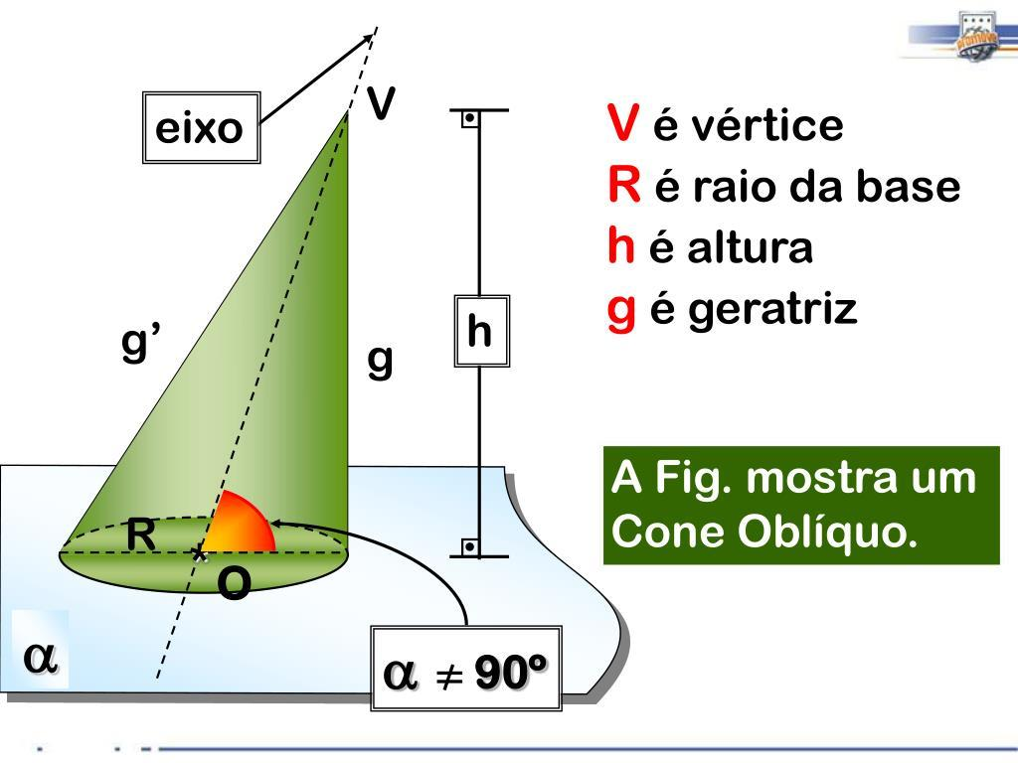
Characteristics:
- The axis is inclined to the base plane.
- The vertex is not directly above or below the center of the circular base.
- Generators generally have different lengths.
- The lateral surface is not symmetric about a perpendicular axis through the base center.

Classification According to the Directrix
# Source: AI Source: Provided by: [Data Path: Persons Table -> ID Column: 1, Name_En Column: Motasem Essam] -> From: [ChatGPT] on [7/25/2026]
The shape of the directrix determines the cross-sectional form of the generated conical surface.

Directrix | Generated surface
Circle | Circular conical surface
Ellipse | Elliptical conical surface
Parabola | Parabolic conical surface
Hyperbola | Hyperbolic conical surface
Polygon | Polygonal pyramidal surface
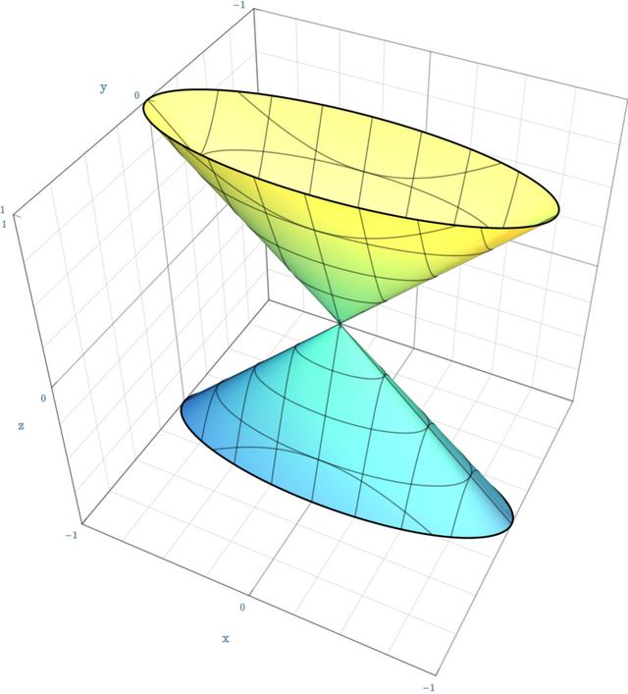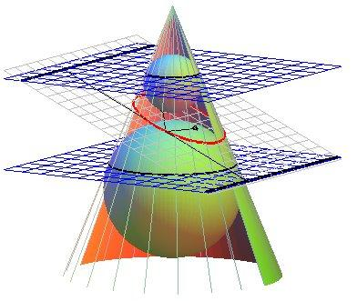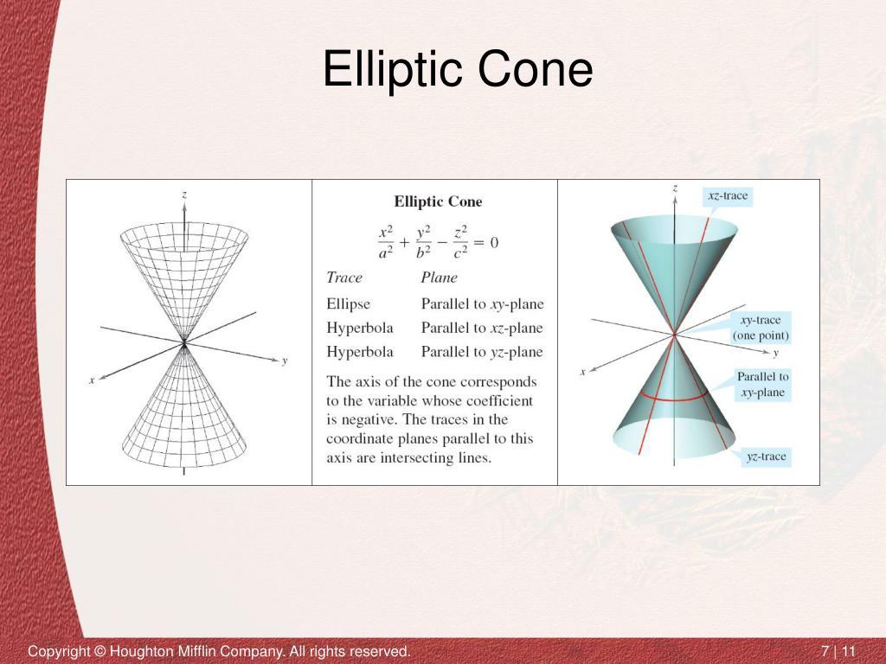
Important distinction: A circular directrix produces a circular cone, while other directrices produce different types of conical surfaces. A polygonal directrix produces a pyramidal surface, which is a polyhedral form of a conical surface.

Mathematical Representation
# Source: AI Source: Provided by: [Data Path: Persons Table -> ID Column: 1, Name_En Column: Motasem Essam] -> From: [ChatGPT] on [7/25/2026]
A conical surface can be represented parametrically by joining a fixed vertex to every point on a directrix.
Let:
- $A$ be the fixed vertex.
- $C(u)$ be a point on the directrix.
- $u$ be the parameter describing the directrix.
- $v$ be the parameter describing the position along each generator.
The general equation is:
$$\boxed{ X(u,v)= A+v[ C(u)- A]}$$
where $v$ describes the generator segment or its extension.
- $v=0$: the vertex.
- $v=1$: the directrix.
- $0<v<1$: points between the vertex and directrix.
For a circular directrix of radius $r$, centered on the vertical axis, with vertex at $(0,0,h)$:
$$x=vrcosu$$
$$y=vrsinu$$
$$z=h(1-v)$$
This describes a right circular conical surface when $0≤v≤1$ and $0≤u<2π$.

Geometric Dimensions and Formulas
# Source: AI Source: Provided by: [Data Path: Persons Table -> ID Column: 1, Name_En Column: Motasem Essam] -> From: [ChatGPT] on [7/25/2026]
For a right circular cone:
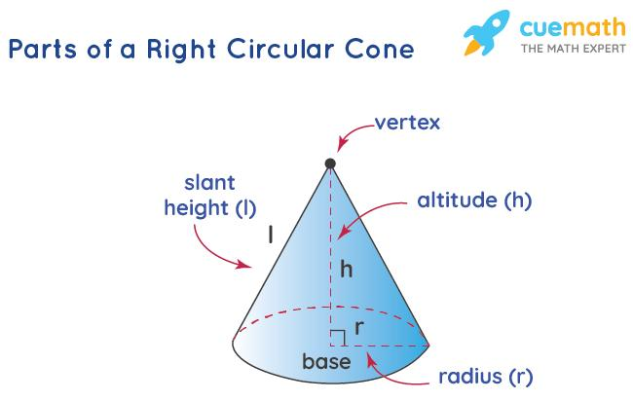
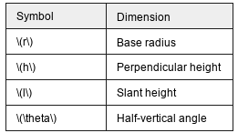
Symbol | Dimension
$$r$$ | Base radius
$$h$$ | Perpendicular height
$$l$$ | Slant height
$$θ$$ | Half-vertical angle
Slant height:
$$l=\sqrt{r^{2}+h^{2}}$$
Base area:
$$A_{b}=πr^{2}$$
Lateral surface area:
$$A_{l}=πrl$$
Total surface area:
$$A_{t}=πr^{2}+πrl$$
Volume:
$$V=\frac{1}{3}πr^{2}h$$
These formulas apply to a right circular cone, not to every possible conical surface.

Mathematical Properties
# Source: AI Source: Provided by: [Data Path: Persons Table -> ID Column: 1, Name_En Column: Motasem Essam] -> From: [ChatGPT] on [7/25/2026]
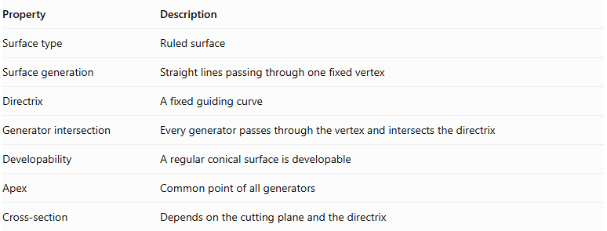
Property | Description
Surface type | Ruled surface
Surface generation | Straight lines passing through one fixed vertex
Directrix | A fixed guiding curve
Generator intersection | Every generator passes through the vertex and intersects the directrix
Developability | A regular conical surface is developable
Apex | Common point of all generators
Cross-section | Depends on the cutting plane and the directrix
A conical surface is a ruled surface because it is formed by straight lines. Its generators converge at the same vertex.

Types According to the Number of Nappes
# Source: AI Source: Provided by: [Data Path: Persons Table -> ID Column: 1, Name_En Column: Motasem Essam] -> From: [ChatGPT] on [7/25/2026]
A conical surface can also be classified according to how much of the generators is considered.

Single-Napped Conical Surface
# Source: AI Source: Provided by: [Data Path: Persons Table -> ID Column: 1, Name_En Column: Motasem Essam] -> From: [ChatGPT] on [7/25/2026]
A single-napped conical surface consists of one portion extending from the vertex in one direction.
It is commonly used to represent an ordinary finite cone or one side of an infinite cone.
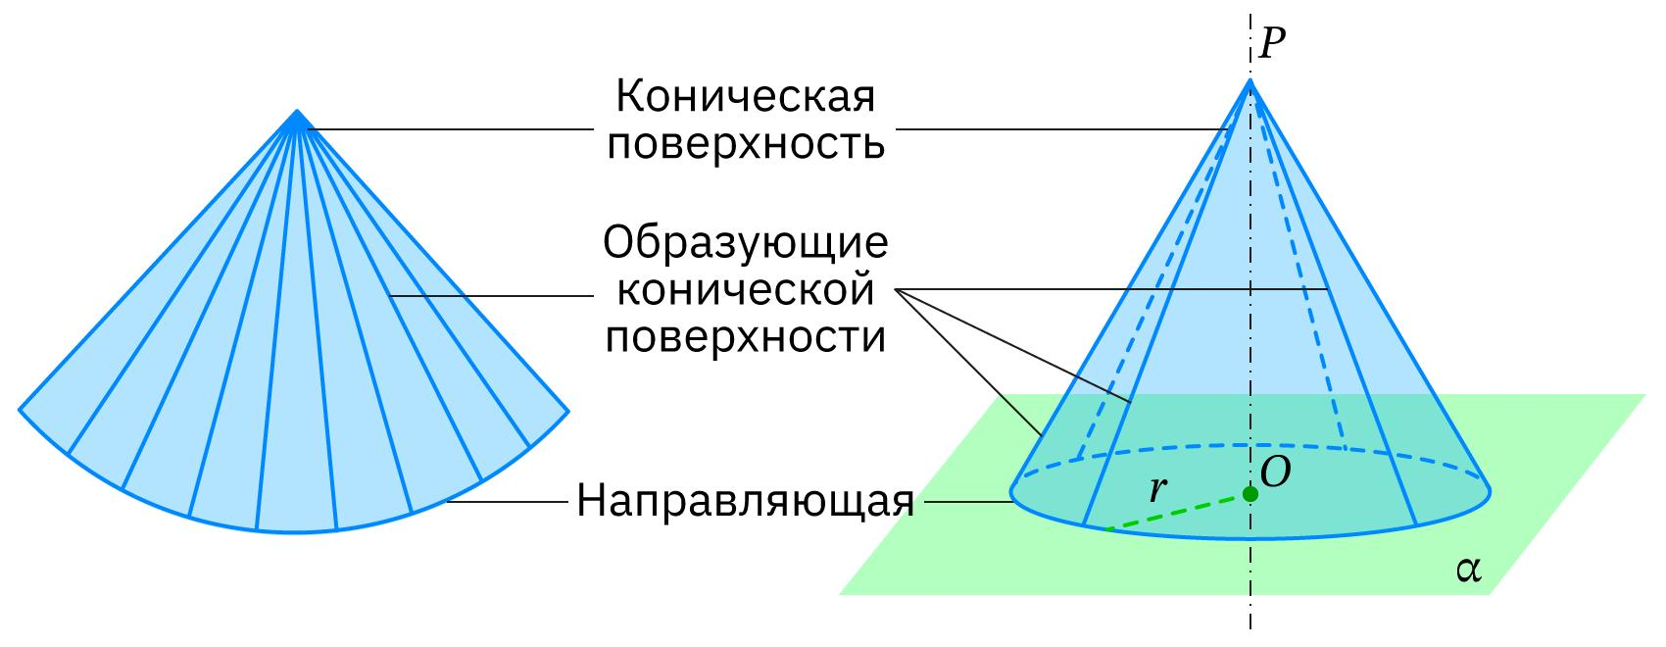

Double-Napped Conical Surface
# Source: AI Source: Provided by: [Data Path: Persons Table -> ID Column: 1, Name_En Column: Motasem Essam] -> From: [ChatGPT] on [7/25/2026]
A double-napped conical surface consists of two portions extending in opposite directions from the same vertex.
The two portions are called nappes, and they meet at the vertex.
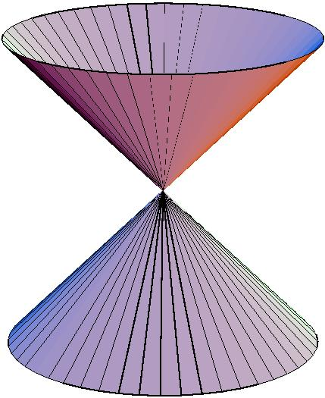
The double cone is particularly important in analytic geometry because its intersection with a plane produces conic sections such as ellipses, parabolas, and hyperbolas.

Relationship to Other Geometric Solids
# Source: AI Source: Provided by: [Data Path: Persons Table -> ID Column: 1, Name_En Column: Motasem Essam] -> From: [ChatGPT] on [7/25/2026]
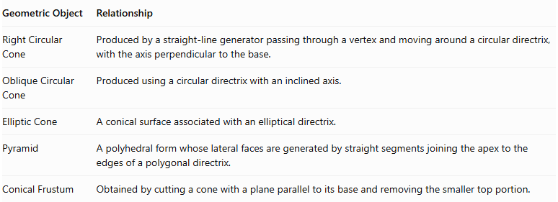
Geometric Object | Relationship
Right Circular Cone | Produced by a straight-line generator passing through a vertex and moving around a circular directrix, with the axis perpendicular to the base.
Oblique Circular Cone | Produced using a circular directrix with an inclined axis.
Elliptic Cone | A conical surface associated with an elliptical directrix.
Pyramid | A polyhedral form whose lateral faces are generated by straight segments joining the apex to the edges of a polygonal directrix.
Conical Frustum | Obtained by cutting a cone with a plane parallel to its base and removing the smaller top portion.
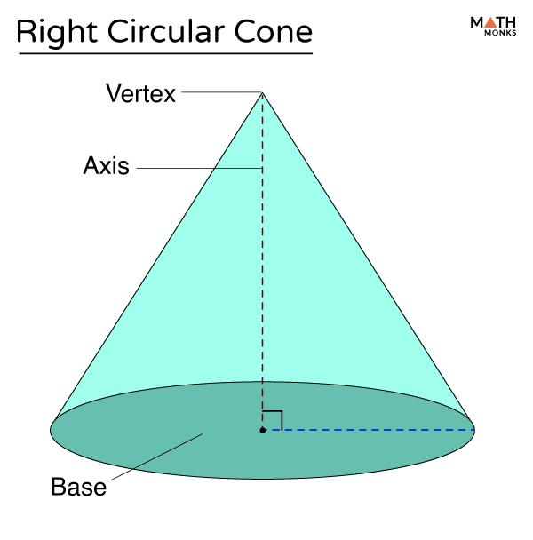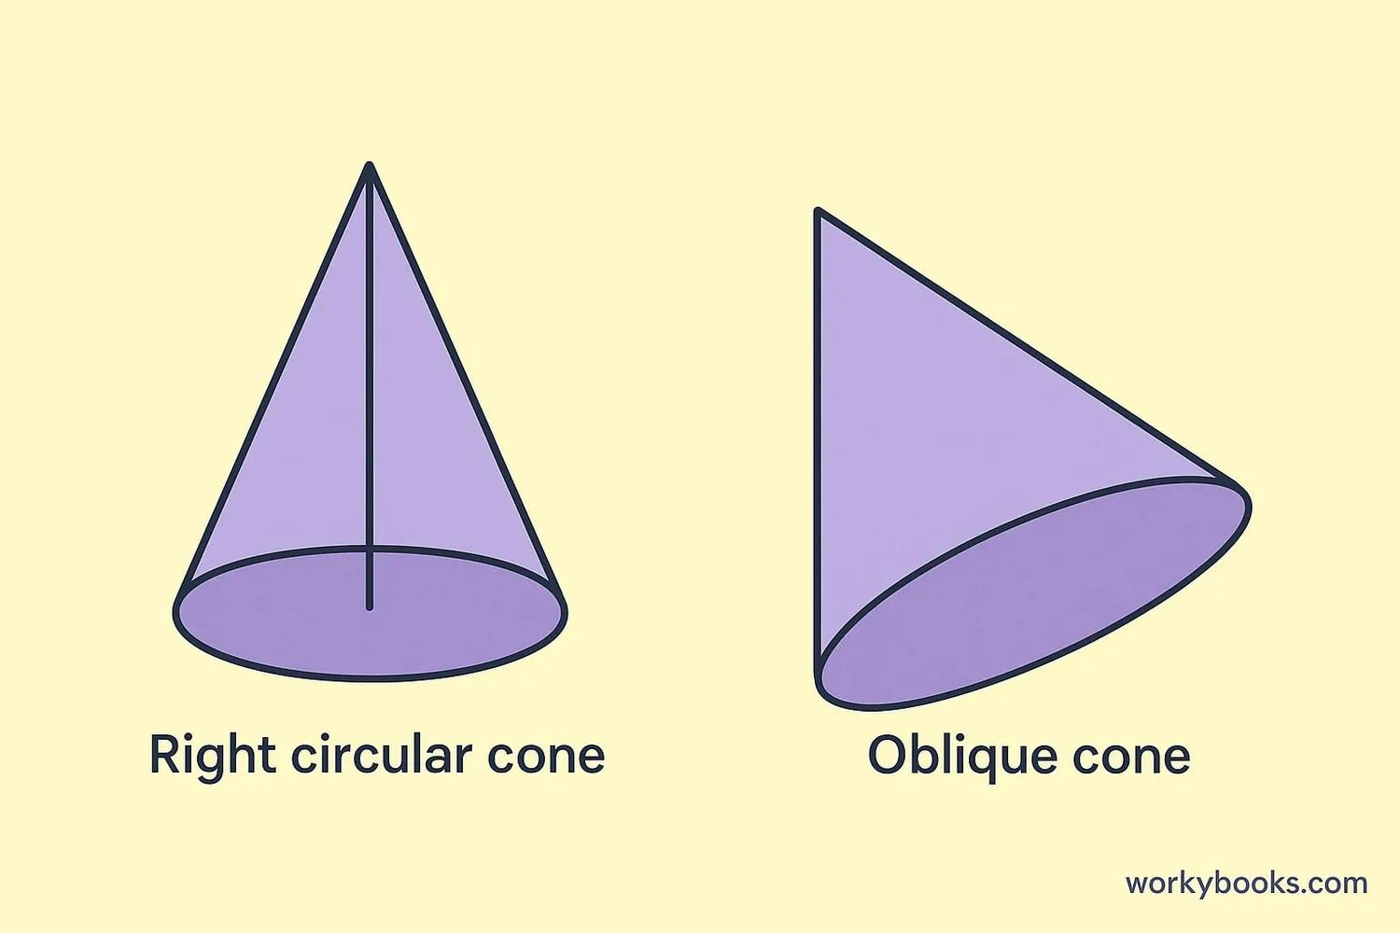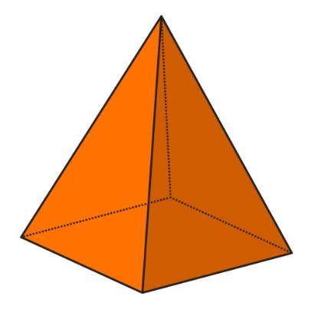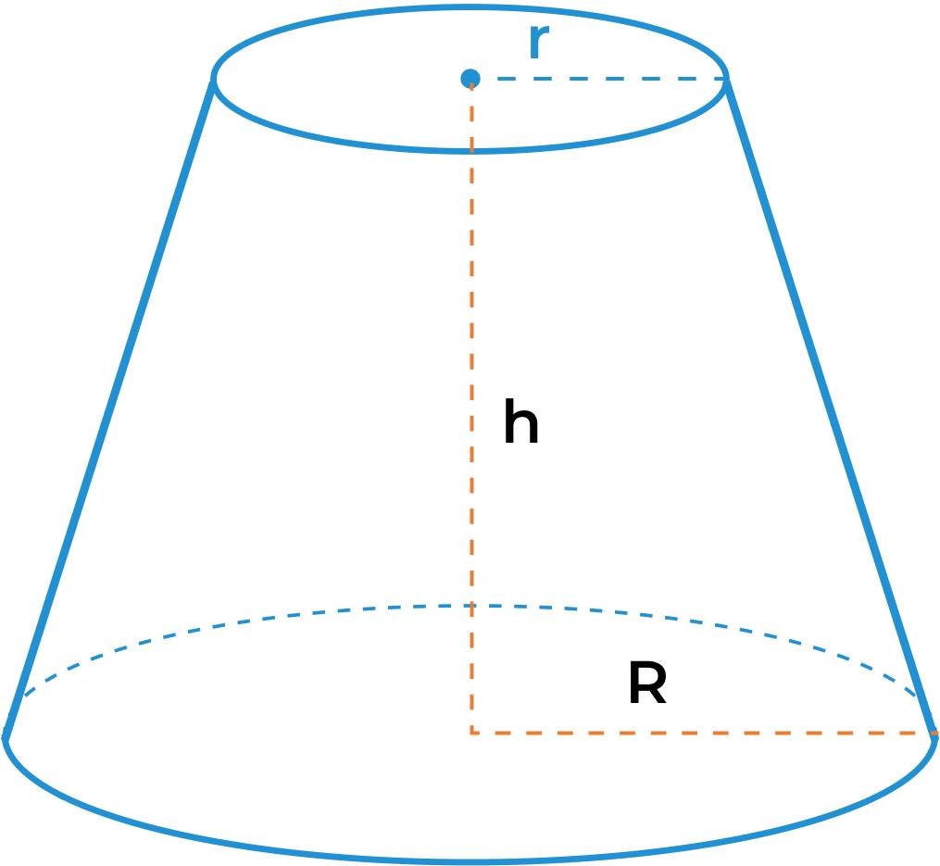

Comparison with Other Straight-Line Generators
# Source: AI Source: Provided by: [Data Path: Persons Table -> ID Column: 1, Name_En Column: Motasem Essam] -> From: [ChatGPT] on [7/25/2026]
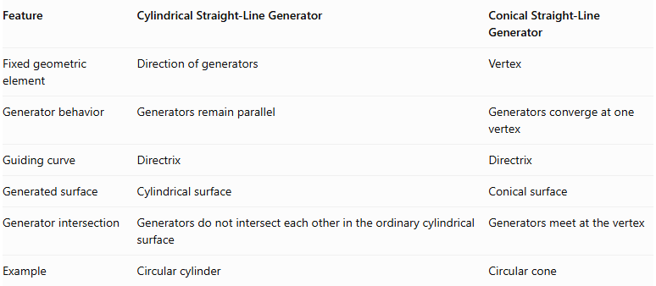
Feature | Cylindrical Straight-Line Generator | Conical Straight-Line Generator
Fixed geometric element | Direction of generators | Vertex
Generator behavior | Generators remain parallel | Generators converge at one vertex
Guiding curve | Directrix | Directrix
Generated surface | Cylindrical surface | Conical surface
Generator intersection | Generators do not intersect each other in the ordinary cylindrical surface | Generators meet at the vertex
Example | Circular cylinder | Circular cone

Main Classification
# Source: AI Source: Provided by: [Data Path: Persons Table -> ID Column: 1, Name_En Column: Motasem Essam] -> From: [ChatGPT] on [7/25/2026]
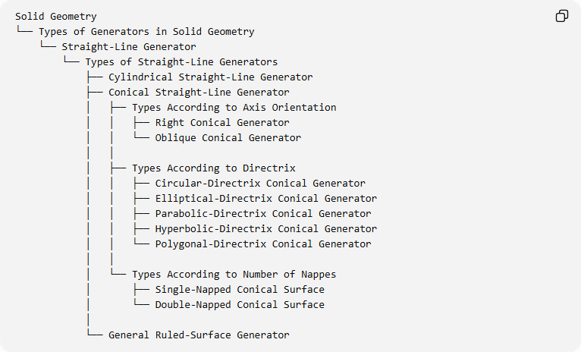
Solid Geometry
└── Types of Generators in Solid Geometry
└── Straight-Line Generator
└── Types of Straight-Line Generators
├── Cylindrical Straight-Line Generator
├── Conical Straight-Line Generator
│ ├── Types According to Axis Orientation
│ │ ├── Right Conical Generator
│ │ └── Oblique Conical Generator
│ │
│ ├── Types According to Directrix
│ │ ├── Circular-Directrix Conical Generator
│ │ ├── Elliptical-Directrix Conical Generator
│ │ ├── Parabolic-Directrix Conical Generator
│ │ ├── Hyperbolic-Directrix Conical Generator
│ │ └── Polygonal-Directrix Conical Generator
│ │
│ └── Types According to Number of Nappes
│ ├── Single-Napped Conical Surface
│ └── Double-Napped Conical Surface
│
└── General Ruled-Surface Generator

Key Points
# Source: AI Source: Provided by: [Data Path: Persons Table -> ID Column: 1, Name_En Column: Motasem Essam] -> From: [ChatGPT] on [7/25/2026]
- A conical straight-line generator is a moving straight line that always passes through a fixed vertex.
- The directrix is the guiding curve that the generator intersects.
- The generated surface is called a conical surface.
- A right cone has an axis perpendicular to its base plane.
- An oblique cone has an axis inclined to its base plane.
- A conical surface can be single-napped or double-napped.
- A pyramid is a polyhedral form generated by straight segments joining an apex to a polygonal directrix.

Conclusion
# Source: AI Source: Provided by: [Data Path: Persons Table -> ID Column: 1, Name_En Column: Motasem Essam] -> From: [ChatGPT] on [7/25/2026]
The Conical Straight-Line Generator is one of the principal types of straight-line generators in solid geometry. It produces conical surfaces through the movement of straight lines passing through a common fixed vertex and intersecting a guiding curve.
Its classification depends on the axis orientation, directrix shape, and number of nappes.

